

Assignment No: 5

Date: 19th October 2026

Title: AMI, Manchester, B3ZS and 4B3T using python

Name: Joe Blogs ???

Course: Bachelor of Engineering in Electronic Engineering

Subject: Digital Communications and Transmission

Lecturer: Ben Graham

Summary: To generate and investigate various line codes (AMI,Manchester,B3ZS and 4B3T) using python

OBJECTIVES:

After the completion of this experiment, students will have a good knowledge of the following line codes:

- Alternate Mark Inversion
- Manchester
- B3ZS
- 4B3T

EQUIPMENT REQUIRED:
Access to python on Kaggle.

THEORY:

AMI A binary 1 is coded as alternate +V and –V for 50% of the bit interval and a binary 0 as 0V for the total bit interval.

Manchester A binary 1 is coded as a +3 V to –3 V transition and a binary 0 as a –3 V to +3 V transition in the middle of the bit interval.

B3ZS Bipolar with Three-Zero Substitution

PST Pair Selected Ternary

4B3T 4 Binary 3 ternary block coding

Total Marks : 100

All work must be completed and submitted inside THIS Document

Part 1 – AMI – (Marks:10)

Question 1: What does AMI stand for? What is the fundamental operation of AMI, explain?

- Using your python code from the previous lab 4, develop python code to generate AMI code for binary input 1011001.

The code will need to monitor the status of the previous mark

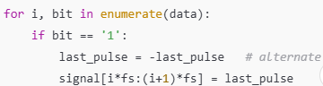

- Include output waveform here

Generate AMI output for ascii ‘U’.

- Include output waveform here

- Comment and explain the key sections of your code

Part B – Manchester – (Marks:20)

Question 2: Explain the key features of Manchester coding
______________________________________________________

Using your python code from the previous lab 4, develop python code to generate Manchester code for binary input 1011001 and for ASCII “!”

- Comment and explain key sections of the code

Hint
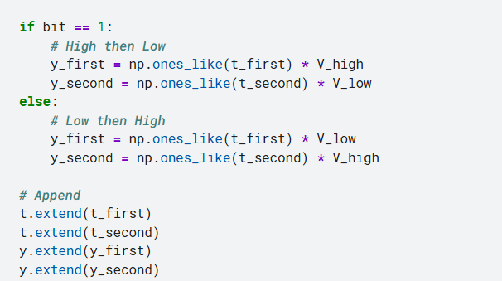

Part C – B3ZS – (Marks:20)

Question 3: Explain your understanding of B3ZS and what conditions need to be taken into account.
_______________________________________________________________

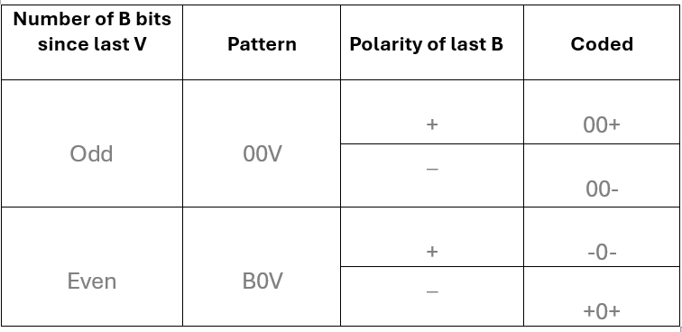

On paper, create the B3ZS waveform for the binary input 1011000101000011.

- Include a picture of your assumptions, calculations, steps and final waveform here.

Develop python code to generate B3ZS for binary input 1011000101000011.

Hint: Code has been created and attached in blackboard
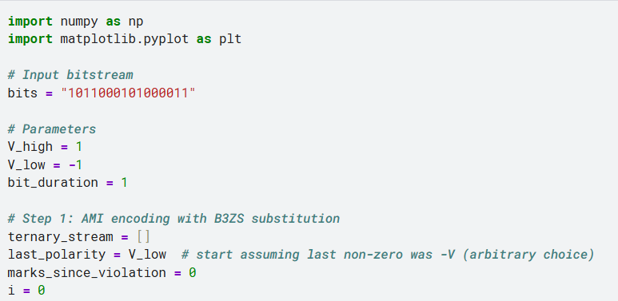
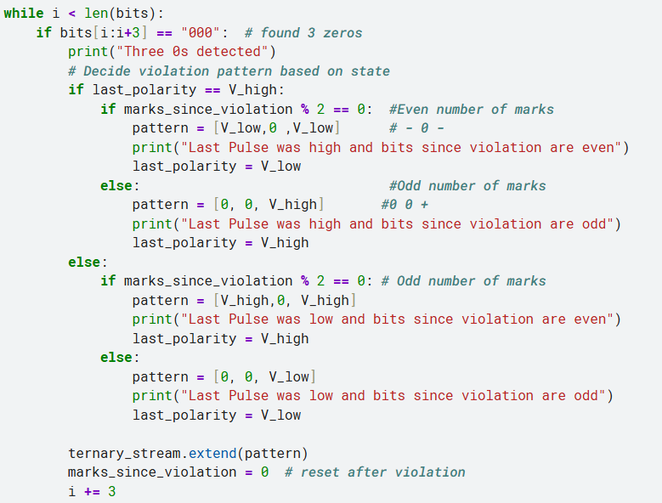
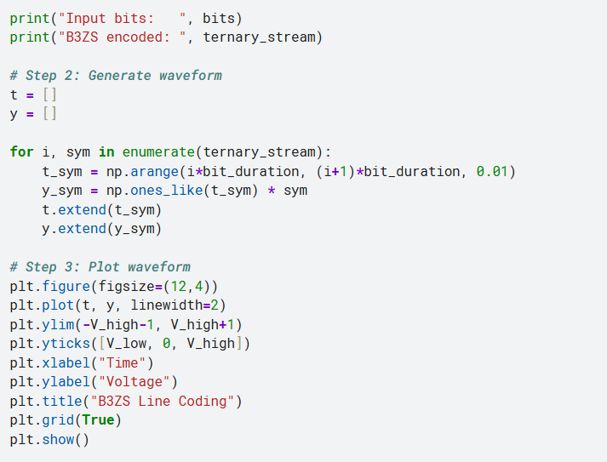

- Walk through the critical parts of your Python script. Outline and explain the core functionality of your Python code.

- Include your generated waveform here. Compare with the waveform you expected.

Repeat for 0x 2C28 (Hex). Assume previous mark was postive (+) and an odd number of marks since last violation.

- Include your generated waveform here. Discuss output

Hint:

Remember to generate the wave form:
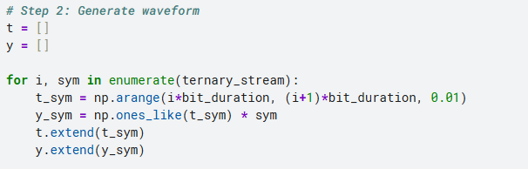

Part D-PST – (Marks:20)

Question 4: Explain your understanding of the operation of PST encoding

____________________________________________________________

- Solve on paper for in 0xB52E (Hex). Assume – Mode to start. Include an image of the output waveform and decisions taken

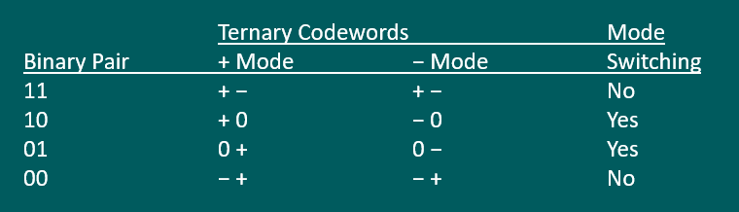

Part E-4B3T – (Marks:20)

Question 5: Explain your understanding of 4B3T, what conditions need to be taken into account and the steps that have to be taken. Refer to Notes

___________________________________________________________________

- Develop the 4B3T coding and output waveform on paper for binary input 101100010100001101011101. Include images of your working out in the report. State any assumptions. Note : I = 1
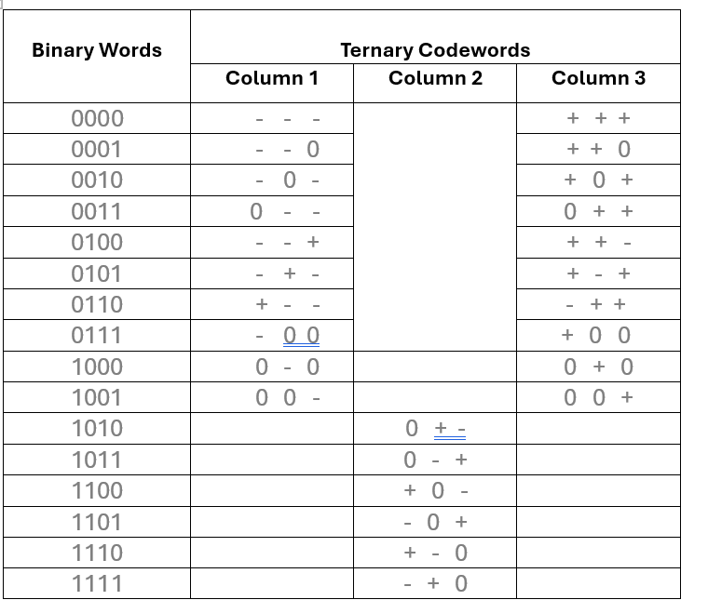

- Using the python code attached, run and confirm if it is correct.

- Highlight and discuss the various sections of the code.

Code shown attached in blackboard:

Part E – Conclusion – (Marks:10)
Explain the main characterises of each coding scheme, the steps taken when creating them and any advantages and disadvantages of each

